

SOFTWARE DESIGN SPECIFICATION
Project Name (Code)

– Hanoi, June 2026 –

Table of Contents
I. Record of Changes 3
II. Software Design Document 4
1. High Level Design 4
1.1 Software Architecture 4
1.2 Package Diagram 5
1.3 Database Design 8
2. State Transition Diagrams 17
3. Detailed Design 25
3.1 <Feature/Function Name1> 25
3.2 <Feature/Function Name2> 26

I. Record of Changes
Date | A*  M, D | In charge | Change Description
9/6/2026 | A | Team | Initial draft
12/6/2026 | M |  | [ai làm phần 1 thì ghi vào đây]
14/6/2026 | A | BinhHD, TungNQ | Add State Transition diagrams and contexts
*A - Added M - Modified D - Deleted

II. Software Design Document

1. High Level Design

1.1 Software Architecture
Overview:The Hotel Management System (HMS) uses a layered web architecture. End users access the system through a web browser on a client device such as a phone, laptop, or PC. The browser sends HTTP requests to the Presentation Logic Layer, and the system returns HTTP responses after processing.
The Presentation Logic Layer contains servlet controllers that receive user requests, control navigation, and call the Service Layer. The View Layer contains JSP pages used to display data and collect user input. The Service Layer handles business logic and works with Model/Entity classes. The Data Access Layer uses DAO and repository classes to query or update the MySQL database. Common and Config classes provide shared utilities such as database connection, authentication filtering, and email support.
The system also connects to external systems. Google OAuth2 Server is used for Google login authentication, while Gmail SMTP Server is used to send email notifications and return email status.

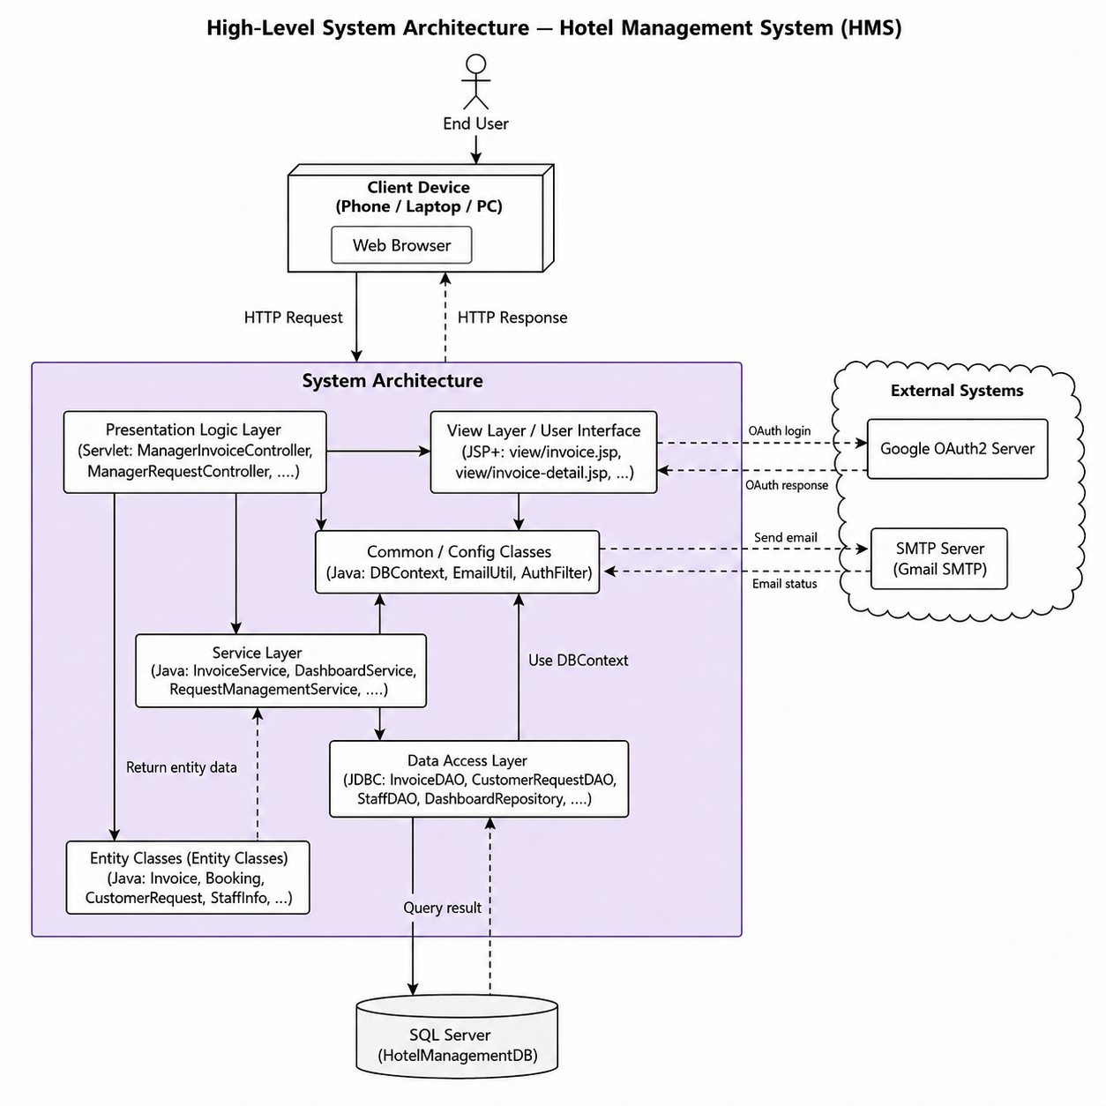-

1.2 Package Diagram
Overview. The Hotel Management System (HMS) is a Jakarta EE 10 web application (Servlet + JSP/JSTL) running on Apache Tomcat, backed by SQL Server through a HikariCP connection pool. It follows a layered (MVC) architecture. All Java source code lives under the single root package com.mycompany.hotelmanagement and is split into six packages (config, entity, filter, dal, service, controller); the JSP views and shared fragments live under webapp/WEB-INF. The package diagram below shows these packages and their relationships. A dashed arrow labelled «import» is a compile-time dependency (Java import); a dashed arrow labelled «access» is a runtime dependency (controller forwards to a view, a view reads model data via JSP EL or includes a fragment, and a filter intercepts controller requests).

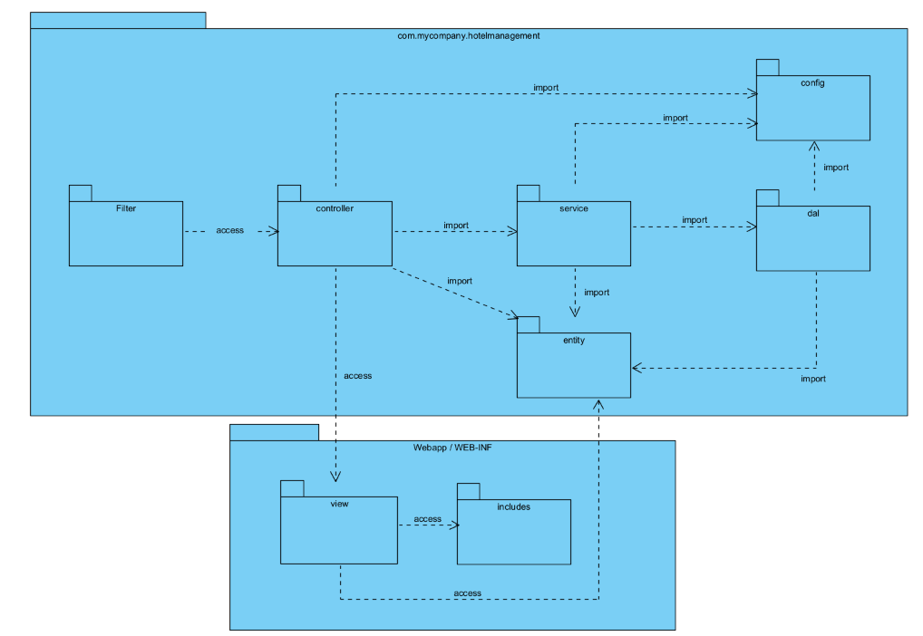
Figure 1.2 - Overall package diagram of the Hotel Management System
Dependency rules: Dependencies only point downward through the layers, keeping the design loosely coupled:
· controller → service, dal, entity, config («import»)
· service → dal, entity, config («import»)
· dal → config, entity («import»)
· entity, config and filter have no internal package dependencies.
· controller → views («access»: request forward); views → entity («access»: JSP EL) and views → includes («access»: include); filter → controller («access»: intercept / guard).
Naming conventions: Packages are all-lowercase, dot-separated, under the root com.mycompany.hotelmanagement. Classes are PascalCase, and each package applies a role-based suffix convention:
· config: Configuration / utility classes (e.g., DBContext, EmailUtil).
· entity: Plain Java objects (POJOs) named after the domain noun (e.g., Invoice, Booking, CustomerRequest, StaffInfo).
· filter: Servlet filters named <Concern>Filter (e.g., AuthFilter, EncodingFilter).
· dal: Data-access classes named <Entity>DAO or <Entity>Repository (e.g., InvoiceDAO, AccountRepository, DashboardRepository).
· service: Business-logic classes named <Feature>Service (e.g., InvoiceService, DashboardService).
· controller: Servlet classes named <Feature>Controller (e.g., ManagerInvoiceController), grouped into role sub-packages: admin, common, manager, receptionist, housekeeping.
· views (JSP): Folder per area (home, dashboard, manager, housekeeping, customer); JSP files use lowercase names (e.g., invoices.jsp, invoice-detail.jsp).
· includes: Shared JSP fragments (e.g., header.jsp, footer.jsp, taglibs.jsp, sidebar.jsp).

Package descriptions
No | Package | Description
01 | config | Application configuration and infrastructure utilities: DBContext (HikariCP connection pool to SQL Server) and EmailUtil (SMTP mail). Used by dal, service and controller.
02 | entity | Domain model layer - POJOs/DTOs representing database rows and view-models (Account, Booking, Invoice, InvoiceItem, Refund, CustomerRequest, StaffInfo, DashboardStats, RoomInfo, RoomTypeInfo, HotelService...). No internal dependencies.
03 | filter | Cross-cutting servlet filters: AuthFilter (role-based access control for /admin, /manager, /receptionist, /housekeeping) and EncodingFilter (UTF-8). Intercepts controller requests.
04 | dal | Data Access Layer - JDBC DAOs/Repositories that read & write the database via DBContext and map rows to entities (InvoiceDAO, CustomerRequestDAO, StaffDAO, BookingDAO, DashboardRepository, RoomRepository, AccountRepository...). Depends on config and entity.
05 | service | Business-logic layer - orchestrates DAOs, validation and derived calculations (InvoiceService, DashboardService, RequestManagementService, AuthService, RoomService, RoomTypeService, HotelServiceService). Depends on dal, entity and config.
06 | controller | Web layer - Jakarta servlets that receive HTTP requests, call services/DAOs and forward to JSP views. Organised into role-based sub-packages. Depends on service, dal, entity and config.
07 | controller.common | Public / shared flows: Login, Logout, Register, Home, Rooms, RoomDetail, Booking, ForgotPassword, ResetPassword, GoogleLogin. Forwards to views/home.
08 | controller.admin | Administrator dashboard. Forwards to views/dashboard.
09 | controller.manager | Manager features: revenue & occupancy dashboard, invoices, customer requests & staff tracking, rooms, room types, services. Forwards to views/manager and views/dashboard.
10 | controller.receptionist | Reception / front-desk: booking handling and receptionist dashboard. Forwards to views/dashboard.
11 | controller.housekeeping | Housekeeping: dashboard and cleaning/maintenance tasks. Forwards to views/housekeeping and views/dashboard.
12 | webapp/WEB-INF/views | JSP view templates grouped by area (home, dashboard, manager, housekeeping, customer). Render the UI; read model data through JSP EL («access» to entity).
13 | webapp/WEB-INF/includes | Shared JSP fragments included by the views (header.jsp, footer.jsp, taglibs.jsp, sidebar.jsp).

1.3 Database Design
[Provide the files description, database table relationship & table descriptions like example below]
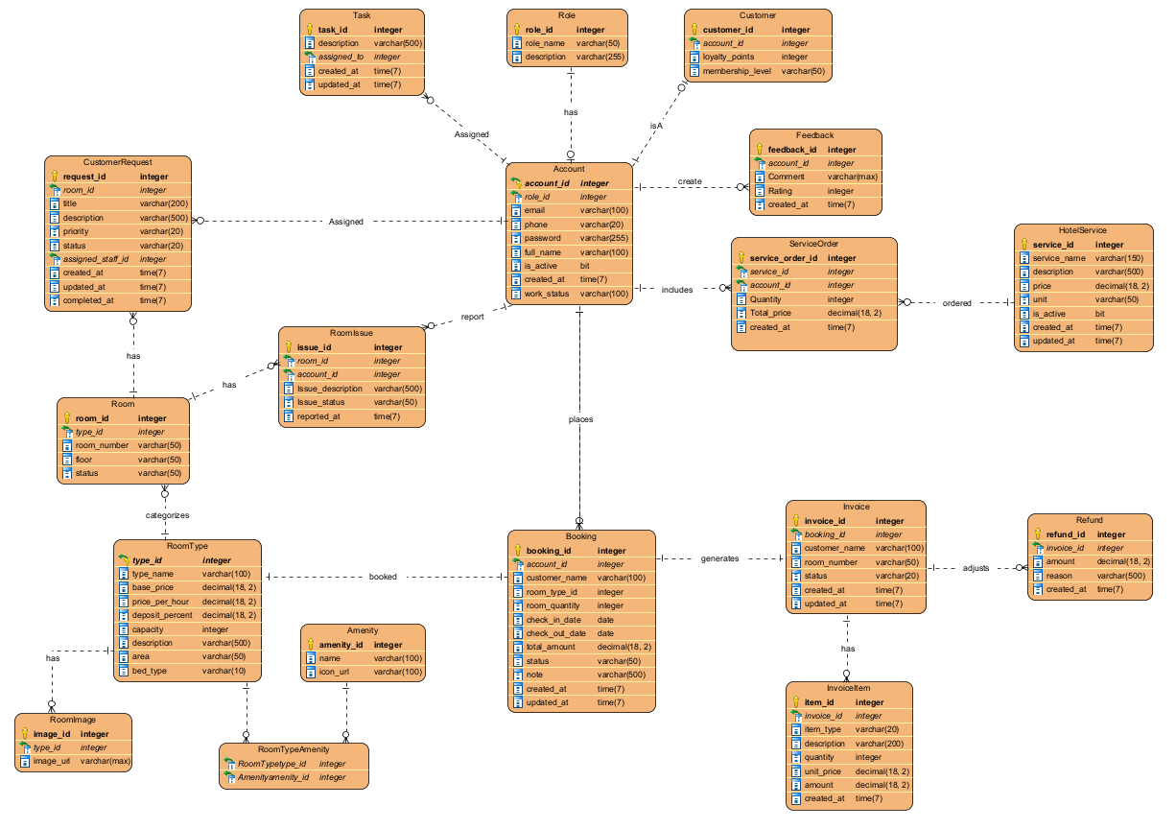

1.3.1 Account
This table stores login credentials and profile information for all system users.
No | Field | PK | FK | UN | NN | Description
01 | account_id | X |  |  | X | Unique identifier for each account
02 | role_id |  | X |  | X | Links to the Role table to determine account permissions
03 | email |  |  |  | X | Email address used for authentication (NVARCHAR(100))
04 | phone |  |  |  |  | Contact phone number (NVARCHAR(20))
05 | password |  |  |  | X | Encrypted account password (NVARCHAR(255))
06 | full_name |  |  |  | X | User's full name (NVARCHAR(100))
07 | is_active |  |  |  | X | Account status flag (BIT: 1-Active, 0-Inactive)
08 | created_at |  |  |  | X | Timestamp when the account was created (DATETIME2(7))
09 | work_status |  |  |  |  | Employment status of the staff member (NVARCHAR(100))

1.3.2 Role
This table stores the system roles and permissions (e.g., Admin, Staff, Customer).
No | Field | PK | FK | UN | NN | Description
01 | role_id | X |  |  | X | Unique identifier for each role
02 | role_name |  |  |  | X | Name of the role (NVARCHAR(50))
03 | description |  |  |  |  | Detailed description of the role's permissions (NVARCHAR(255))

1.3.3 Customer
This table extends the specific profile information for customer accounts (IsA inheritance relationship from Account).
No | Field | PK | FK | UN | NN | Description
01 | customer_id | X |  |  | X | Unique identifier for the customer
02 | account_id |  | X |  | X | Links directly to the base profile in the Account table
03 | loyalty_points |  |  |  | X | Total accumulated loyalty points of the customer
04 | membership_level |  |  |  |  | Membership tier level (NVARCHAR(50) - e.g., Silver, Gold, Diamond)

1.3.4 RoomType
This table defines the categories of rooms available in the hotel along with their pricing policies.
No | Field | PK | FK | UN | NN | Description
01 | type_id | X |  |  | X | Unique identifier for each room type
02 | type_name |  |  |  | X | Name of the room type (NVARCHAR(100) - e.g., Deluxe, Standard)
03 | base_price |  |  |  | X | Standard daily room rate (DECIMAL(18,2))
04 | price_per_hour |  |  |  | X | Hourly room rate (DECIMAL(18,2))
05 | deposit_percent |  |  |  | X | Required reservation deposit percentage (DECIMAL(18,2))
06 | capacity |  |  |  | X | Maximum number of guests allowed in the room
07 | description |  |  |  |  | Detailed description of the room type features (NVARCHAR(500))
08 | area |  |  |  |  | Room size/floor area measurements (NVARCHAR(50))
09 | bed_type |  |  |  |  | Type of bedding configuration provided (NVARCHAR(10))

1.3.5 Room

This table stores information regarding individual, physical rooms located within the hotel.
No | Field | PK | FK | UN | NN | Description
01 | room_id | X |  |  | X | Unique identifier for each physical room
02 | type_id |  | X |  | X | Links to RoomType to inherit room configurations and rates
03 | room_number |  |  |  | X | Designated room number (NVARCHAR(50))
04 | floor |  |  |  | X | Floor level where the room is located (NVARCHAR(50))
05 | status |  |  |  | X | Current room condition (NVARCHAR(50) - e.g., Available, Occupied, Maintenance)

1.3.6 Booking
This table manages all customer room reservation transactions.
No | Field | PK | FK | UN | NN | Description
01 | booking_id | X |  |  | X | Unique identifier for the reservation order
02 | account_id |  | X |  | X | Account that placed the booking order
03 | customer_name |  |  |  | X | Name of the primary guest representing the booking (NVARCHAR(100))
04 | room_type_id |  | X |  | X | The category of room selected for reservation
05 | room_quantity |  |  |  | X | Total number of rooms reserved under this order
06 | check_in_date |  |  |  | X | Expected arrival/check-in date (DATE)
07 | check_out_date |  |  |  | X | Expected departure/check-out date (DATE)
08 | total_amount |  |  |  | X | Estimated grand total cost for the stay duration (DECIMAL(18,2))
09 | status |  |  |  |  | Current order processing state (NVARCHAR(50) - e.g., Deposited, Cancelled)
10 | note |  |  |  |  | Special customer requests or instructions (NVARCHAR(500))
11 | created_at |  |  |  | X | Timestamp when the reservation was initially created (DATETIME2(7))
12 | updated_at |  |  |  | X | Timestamp of the latest reservation update (DATETIME2(7))

1.3.7 Invoice
This table contains overall billing information generated upon guest check-out or service completion.
No | Field | PK | FK | UN | NN | Description
01 | invoice_id | X |  |  | X | Unique identifier for the transaction invoice
02 | booking_id |  | X |  | X | Links directly to the corresponding reservation order
03 | customer_name |  |  |  | X | Name of the customer being billed (NVARCHAR(100))
04 | room_number |  |  |  | X | Actual assigned room number utilized during the stay (NVARCHAR(50))
05 | status |  |  |  | X | Payment settlement status (NVARCHAR(20) - e.g., Paid, Pending)
06 | created_at |  |  |  | X | Timestamp when the invoice was issued (DATETIME2(7))
07 | updated_at |  |  |  | X | Timestamp of the most recent modifications to the bill (DATETIME2(7))

1.3.8 InvoiceItem
This table stores granular line items or individual breakdown charges tied to a parent invoice (e.g., Room nights, service fees).
No | Field | PK | FK | UN | NN | Description
01 | item_id | X |  |  | X | Unique identifier for individual billing entries
02 | invoice_id |  | X |  | X | Parent invoice ID this charge line belongs to
03 | item_type |  |  |  | X | Category of the charge (NVARCHAR(20) - e.g., Room, Service)
04 | description |  |  |  | X | Itemized text description of the specific charge (NVARCHAR(200))
05 | quantity |  |  |  | X | Quantity consumed or days stayed
06 | unit_price |  |  |  | X | Unit cost of the item at the transaction point (DECIMAL(18,2))
07 | amount |  |  |  | X | Computed total charge amount derived from Quantity X Unit_Price (DECIMAL(18,2))
08 | created_at |  |  |  | X | Timestamp when this specific entry was logged (DATETIME2(7))

1.3.9 HotelService
This table outlines the catalogue of extra amenities or service offerings provided by the hotel (e.g., Laundry, Spa, Restaurant, Minibar).
No | Field | PK | FK | UN | NN | Description
01 | service_id | X |  |  | X | Unique identifier for the hotel service
02 | service_name |  |  |  | X | Display name of the service (NVARCHAR(150))
03 | description |  |  |  |  | Elaborate breakdown of what the service entails (NVARCHAR(500))
04 | price |  |  |  | X | Standard base charge per single unit of service (DECIMAL(18,2))
05 | unit |  |  |  | X | Measurement metric unit (NVARCHAR(50) - e.g., Session, Can, Hour)
06 | is_active |  |  |  | X | Operational availability indicator of the service (BIT)
07 | created_at |  |  |  | X | Timestamp when the service was registered into the catalogue (DATETIME2(7))
08 | updated_at |  |  |  |  | Timestamp of the last modifications to the service rules (DATETIME2(7))

1.3.10 Service_Order
This table registers individual requests or purchases for extra hotel services placed by customers or staff.
No | Field | PK | FK | UN | NN | Description
01 | service_order_id | X |  |  | X | Unique identifier for the service order transaction
02 | service_id |  | X |  | X | Specific item requested from the HotelService catalogue
03 | account_id |  | X |  |  | Account holder that requested or placed the service order
04 | quantity |  |  |  | X | Ordered quantity count
05 | total_price |  |  |  | X | Total aggregated transaction cost for this service request (DECIMAL(18,2))
06 | created_at |  |  |  | X | Timestamp when the service request was made (DATETIME2(7))

1.3.11 CustomerRequest
This table receives and tracks operational, custom requests submitted by in-house guests from their assigned rooms.
No | Field | PK | FK | UN | NN | Description
01 | request_id | X |  |  | X | Unique identifier for the special request item
02 | room_id |  | X |  | X | Physical room location origin of the request
03 | title |  |  |  | X | Brief summary header of the guest request (NVARCHAR(200))
04 | description |  |  |  | X | Comprehensive description detailing the specific inquiry (NVARCHAR(500))
05 | priority |  |  |  | X | Urgency ranking level (NVARCHAR(20) - e.g., High, Medium, Low)
06 | status |  |  |  | X | Resolution tracking step (NVARCHAR(20) - e.g., Pending, In Progress, Resolved)
07 | assigned_staff_id |  |  |  |  | Account ID of the staff member tasked to handle this request
08 | created_at |  |  |  | X | Timestamp when the ticket request was submitted (DATETIME2(7))
09 | updated_at |  |  |  | X | Timestamp of the latest ticket activity changes (DATETIME2(7))
10 | completed_at |  |  |  |  | Exact timestamp when the task was completely resolved (DATETIME2(7))

1.3.12 Room_Issue
This table tracks physical damage, facility malfunctions, or issues regarding room assets reported by guests or inspectors.
No | Field | PK | FK | UN | NN | Description
01 | (room_id, account_id) | X | X |  | X | Composite Primary Key pairing the affected Room and reporting Account
02 | issue_description |  |  |  | X | Explicit text description outlining the ongoing asset/room issue
03 | issue_status |  |  |  | X | Operational status regarding repairing or addressing the failure
04 | reported_at |  |  |  | X | Timestamp marking when the issue was reported to the desk

1.3.13 Task
This table handles administrative internal task assignments dispatched to staff members.
No | Field | PK | FK | UN | NN | Description
01 | task_id | X |  |  | X | Unique identifier for the operational task assignation
02 | description |  |  |  | X | Granular details describing the workload duty requirements (NVARCHAR(500))
03 | assigned_to |  | X |  | X | Account ID of the designated staff employee handling the assignment
04 | created_at |  |  |  | X | Timestamp when the task assignment order was created (DATETIME2(7))
05 | updated_at |  |  |  | X | Timestamp tracking subsequent adjustments to the task status (DATETIME2(7))

1.3.14 Feedback
This table stores rating scores, qualitative reviews, and feedback sent by guests regarding hotel operations.

No | Field | PK | FK | UN | NN | Description
01 | feedback_id | X |  |  | X | Unique identifier for the feedback submission
02 | account_id |  | X |  | X | Guest account identity providing the experience review
03 | comment |  |  |  |  | Extended qualitative evaluation text feedback entries (NVARCHAR(MAX))
04 | rating |  |  |  | X | Quantitative numerical evaluation score metric (INT - e.g., 1 to 5 stars)
05 | created_at |  |  |  | X | Timestamp indicating exactly when the review was sent (DATETIME2(7))

1.3.15 Refund
This table handles financial reversal processes or refunds executed due to order modifications or cancellations.
No | Field | PK | FK | UN | NN | Description
01 | refund_id | X |  |  | X | Unique identifier for the payout refund record
02 | invoice_id |  | X |  | X | Target modified invoice reference where adjustments were required
03 | amount |  |  |  |  | Exact total money value returned back to the customer (DECIMAL(18,2))
04 | reason |  |  |  | X | Declared operational justification explaining the refund cause (NVARCHAR(500))
05 | created_at |  |  |  | X | Timestamp outlining when the monetary refund occurred (DATETIME2(7))

1.3.16 RoomImage
This table houses image URLs showcasing the interior/exterior designs of specific room classes.
No | Field | PK | FK | UN | NN | Description
01 | image_id | X |  |  | X | Unique identifier for the imagery record entries
02 | type_id |  | X |  | X | Links specific assets back to the parent RoomType structure
03 | image_url |  |  |  | X | Absolute web file system storage directory locator address path (NVARCHAR(MAX))

1.3.17 Amenity
This table acts as a global master catalogue containing general room perks, furniture items, or facilities (e.g., WiFi, AC, Pool, Fridge).

No | Field | PK | FK | UN | NN | Description
01 | amenity_id | X |  |  | X | Unique identifier for the utility feature asset
02 | name |  |  |  |  | Descriptive name defining the facility amenity (NVARCHAR(100))
03 | icon_url |  |  |  |  | Media asset link for visual representation icons (NVARCHAR(100))

1.3.18 RoomType_Amenity
A bridging junction table used to resolve the Many-to-Many relationship matrix map between RoomType and Amenity models.
No | Field | PK | FK | UN | NN | Description
01 | type_id | X | X |  | X | Room Type key constraint defining the composite primary block
02 | amenity_id | X | X |  | X | Amenity catalog item index completing the composite primary block

2. State Transition Diagrams

2.1 Booking protocol
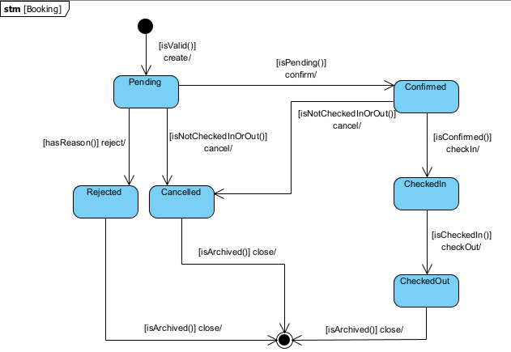
This protocol state machine diagram illustrates the lifecycle of a Booking entity and its business rules:
- Creation: A new booking is initialized in the Pending state upon passing the [isValid()] data validation.
- Processing: The receptionist can confirm a pending booking (moving it to Confirmed) or reject it. The [hasReason()] guard strictly requires a rejection reason to proceed to the Rejected state.
- Cancellation Flow: Bookings can be cancelled from either Pending or Confirmed states. The [isNotCheckedInOrOut()] guard acts as a security check to prevent cancellation once a guest has checked in or out.
- Stay Execution: A Confirmed booking sequentially transitions to CheckedIn upon guest arrival, and subsequently to CheckedOut upon departure and payment settlement.
- End of Lifecycle: Rejected, Cancelled, and CheckedOut are terminal states. Upon reaching these, the booking record is archived (close/), leading to the Final State.

2.2 Customer Request Protocol
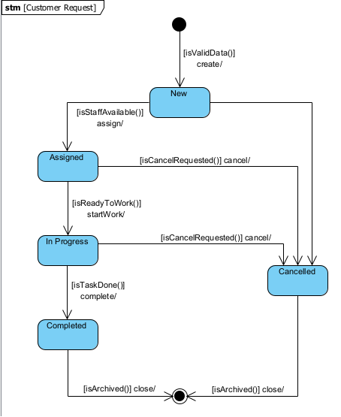
This protocol state machine diagram illustrates the lifecycle of a Customer Request entity:
- Creation: A request is initialized in the New state after passing the [isValidData()] validation check.
- Execution Flow: The request follows a linear progression. It transitions to Assigned when staff becomes available ([isStaffAvailable()]), moves to In Progress when the staff begins working ([isReadyToWork()]), and finally reaches Completed once the task is finished ([isTaskDone()]).
- Cancellation Flow: A request can be aborted at almost any active phase. If the user or system triggers a cancellation (cancel/) while the request is New, Assigned, or In Progress, it immediately transitions to the Cancelled state.
- End of Lifecycle: Completed and Cancelled serve as the terminal states for this entity. Once the records are processed or archived ([isArchived()] close/), the object reaches the Final State, concluding its lifecycle

2.3 Room Protocol

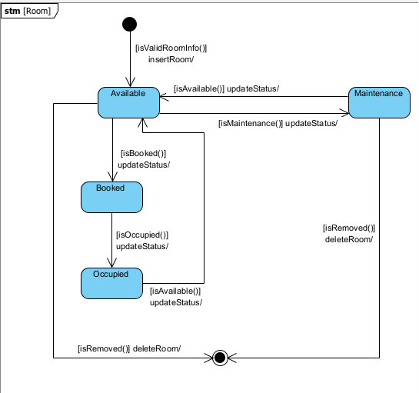
This protocol state machine diagram illustrates the lifecycle of a Room entity and its operational constraints:
- Creation: A new room is added to the system and initialized in the Available state upon passing the [isValidRoomInfo()] validation during the insertRoom action.
- Booking & Occupation Flow: An Available room transitions to Booked when reserved ([isBooked()]), and then to Occupied upon guest check-in ([isOccupied()]). After the guest checks out and the room is cleaned, it reverts to Available.
- Maintenance: If an issue is reported or scheduled upkeep is required, an Available room is temporarily taken out of service, moving to the Maintenance state ([isMaintenance()]). Once repaired, it is restored to Available.
- End of Lifecycle: A room can be permanently removed from the database (deleteRoom/) only when it is Available or in Maintenance. The [isRemoved()] guard ensures that rooms currently involved in active bookings (Booked or Occupied) cannot be deleted. This transitions the object to the Final State.

2.4 Invoice Protocol

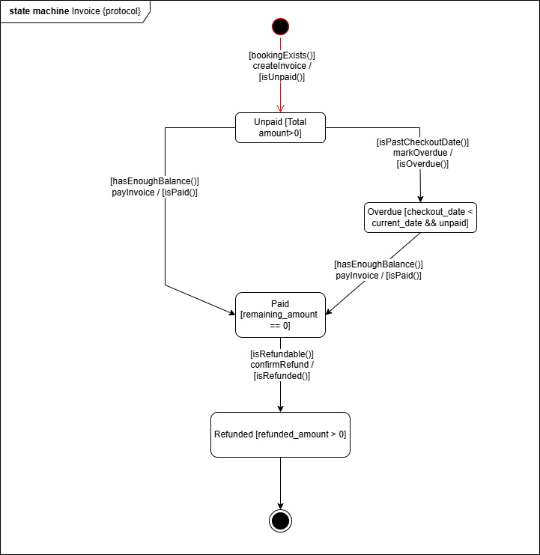
This protocol state machine diagram illustrates the lifecycle of an Invoice entity and its business rules:
- Creation: A new invoice is initialized in the Unpaid state via the createInvoice transition upon passing the [bookingExists()] validation. This transition guarantees an [isUnpaid()] post-condition. At this stage, the invoice maintains a state invariant of [Total amount>0].
- Payment Flow: From the Unpaid state, the invoice can directly transition to the Paid state (where the invariant becomes [remaining_amount == 0]) via the payInvoice trigger, guarded by [hasEnoughBalance()], resulting in the [isPaid()] post-condition.
- Overdue Processing: If an invoice is not settled on time, an Unpaid invoice can transition to the Overdue state (with the invariant [checkout_date < current_date && unpaid]) via the markOverdue trigger, guarded by [isPastCheckoutDate()] and guaranteeing [isOverdue()]. From the Overdue state, it can still be settled and moved to the Paid state using the same payInvoice transition.
- Refund Flow: A Paid invoice can transition to the Refunded state (where the invariant is [refunded_amount > 0]) via the confirmRefund trigger. This action requires the [isRefundable()] guard to be true and ensures the [isRefunded()] post-condition.
- End of Lifecycle: Upon reaching the Refunded state, the invoice lifecycle is concluded, leading directly to the Final State.

2.5 Account Protocol
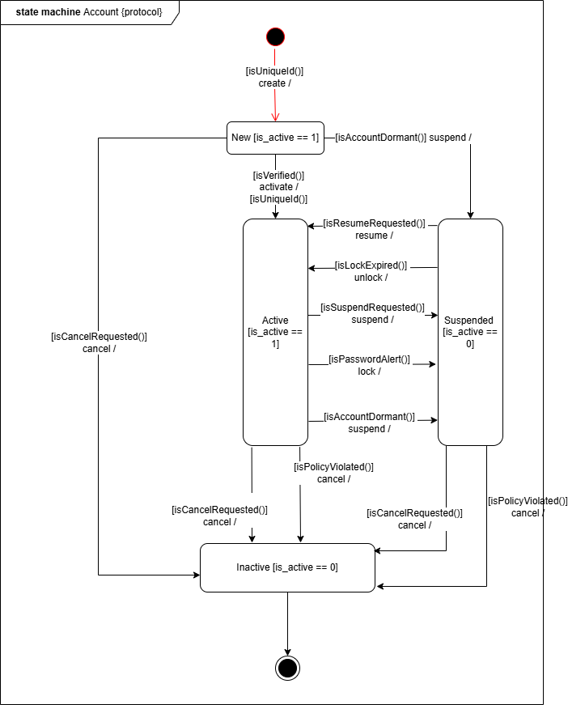
This protocol state machine diagram illustrates the lifecycle of an Account entity and its business rules:

- Creation: A new account is initialized in the New state via the create transition upon passing the -[isUniqueId()] data validation. At this stage, the account maintains a state invariant of [is_active == 1].
- Activation: The account can be activated, moving it from the New state to the Active state. The [isVerified()] guard ensures the account is verified before activation, and the transition guarantees an [isUniqueId()] post-condition.
- Suspension Flow: An Active account can transition to the Suspended state (where the invariant becomes [is_active == 0]) through various triggers: suspend (guarded by [isSuspendRequested()] or [isAccountDormant()]) or lock (guarded by [isPasswordAlert()]). The account can sequentially return to Active when the user requests a resume (guarded by [isResumeRequested()]) or when the system triggers an unlock (guarded by [isLockExpired()]).
- Cancellation Flow: Accounts can be cancelled from the New, Active, or Suspended states. The [isCancelRequested()] or [isPolicyViolated()] guards act as conditions to terminate the account, moving it to the Inactive state (where [is_active == 0]).
- End of Lifecycle: Inactive is a terminal state. Upon reaching this state, the account lifecycle is concluded, leading directly to the Final State.

2.6 Room_Issue Protocol
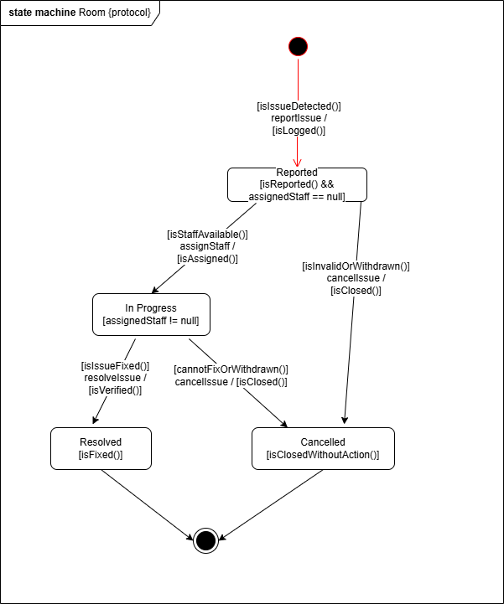
This protocol state machine diagram illustrates the lifecycle of a Room Issue entity and its business rules:
- Creation: A new issue is initialized in the Reported state via the reportIssue transition upon passing the [isIssueDetected()] validation. This transition guarantees an [isLogged()] post-condition. At this stage, the issue maintains a state invariant of [isReported() && assignedStaff == null].
- Assignment Flow: From the Reported state, the issue can transition to the In Progress state (where the invariant becomes [assignedStaff != null]) via the assignStaff trigger. This action is guarded by [isStaffAvailable()] and ensures the [isAssigned()] post-condition.
- Resolution Flow: An In Progress issue can transition to the Resolved state (with the invariant [isFixed()]) via the resolveIssue trigger. This requires the [isIssueFixed()] guard to be true and guarantees the [isVerified()] post-condition.
- Cancellation Flow: Issues can be cancelled and moved to the Cancelled state (where the invariant is [isClosedWithoutAction()]) from two different stages via the cancelIssue trigger. From the Reported state, it is guarded by [isInvalidOrWithdrawn()]. From the In Progress state, it is guarded by [cannotFixOrWithdrawn()]. Both paths result in an [isClosed()] post-condition.
- End of Lifecycle: Resolved and Cancelled are terminal states. Upon reaching either of these states, the issue lifecycle is concluded, leading directly to the Final State.

3. Detailed Design

3.1 <Feature/Function Name1>
[Provide the detailed design for the feature <Feature Name1>. It includes Class Diagram and Sequence Diagram(s); For the features/functions with the same structure of class & sequence diagrams, you need to provide the diagrams once for one feature/function and refer to those diagrams from other features/functions]

Dùng 1 case để diễn đạt 1 detail feature/function -> detailed design còn gọi là UC design
Một bạn đảm nhận X use case trong Project tracking sẽ phải thiết kế X use cases trong sơ đồ implementation class diagram và X sơ đồ sequence diagram

3.1.1 Class Diagram
[This part presents the implementation class diagram for the relevant feature]
Mỗi class đại diện cho một 1 class trong lập trình hướng đối tượng.
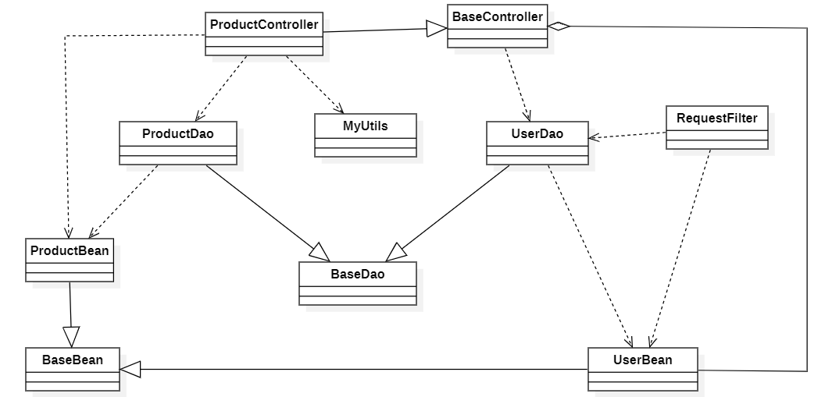

3.1.2 <Sequence Diagram Name1>
[Provide the sequence diagram(s) for the feature, see the sample below]
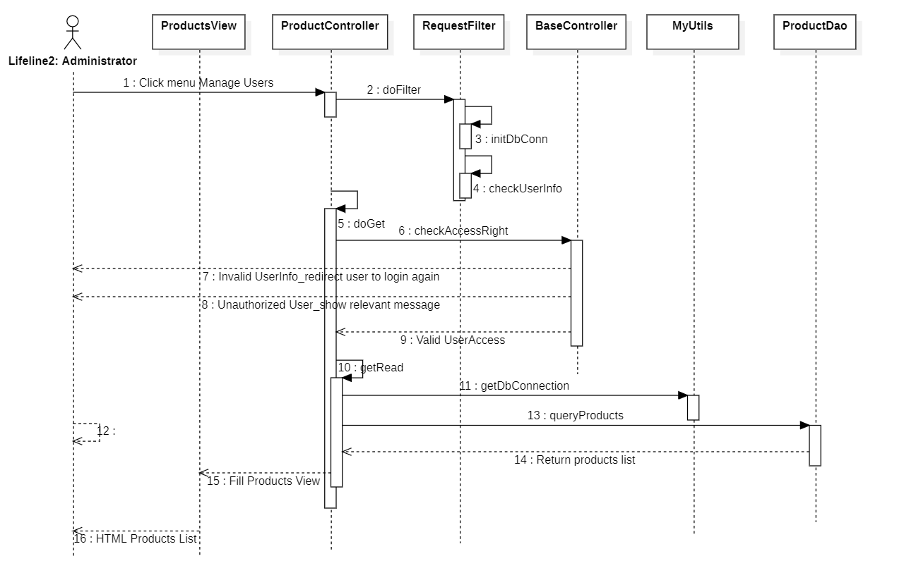

3.1.3 <Sequence Diagram Name2>

3.1.4 …

3.2 <Feature/Function Name2>
…

